Chapter 2 – Probability Homework

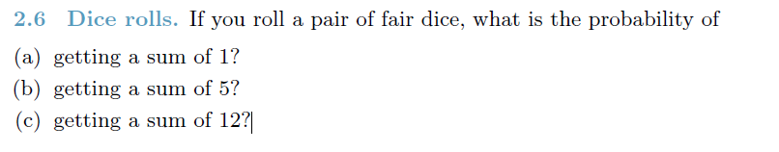

**Ans:**

1. P(1) = 0 (The minimum sum that we get with a fair dice is 2. So getting a 1 is not possible)
2. P(5) = 4 / 36 = 1 / 9 = 0.111
3. P(12) = 1 / 36 = 0.0278

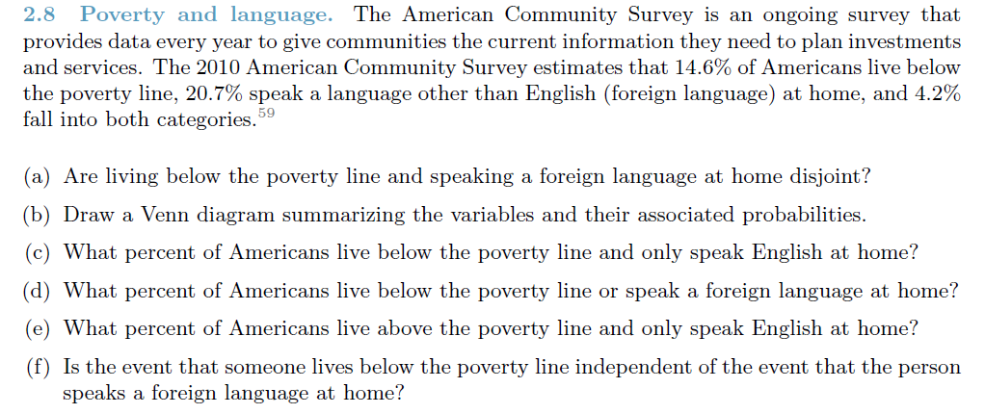

**Ans:**

1. No, they are not disjoint. There is a 4.2% that belong to both groups.
2. Below is the diagram

Other than English

Below Poverty

16.5%

4.2%

10.4%

Above Poverty & English: 68.9%

1. 10.4% of the Americans live below poverty line and only speak English.
2. 31.1% (10.4 + 4.2 + 16.5) of the Americans live below poverty line and only a foreign language.
3. 68.9% of the Americans live above the poverty line and speak English at home.
4. If the events are independent then P(BPL | FL) = P(BPL)

Now P(BPL | FL) = P(BPL and FL) / P(FL) = 4.2% / 20.7% = 20.3% which is != 14.6%.

Hence the 2 events are dependent.

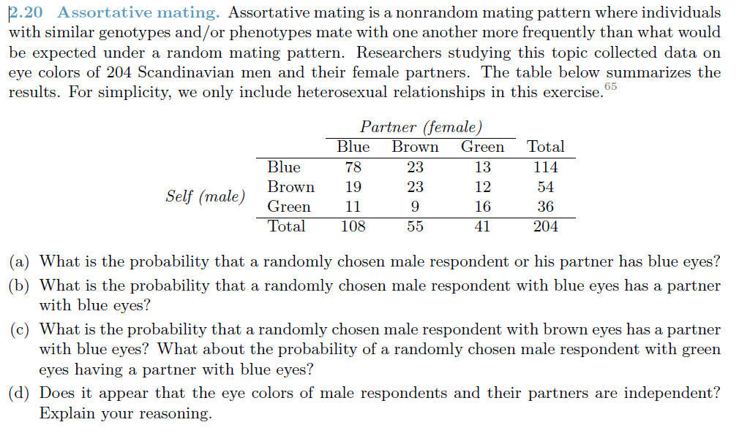

**Ans:**

1. P( Male-Blue or Female-Blue) = P(Male-Blue) + P(Female-Blue) - P( Male-Blue and Female-Blue)

= (114 / 204) + (108 / 204) – (78 / 204) = (114 + 108 – 78) / 204 **= 0.70588** **= 70.59%**

1. P(Female-Blue | Male-Blue) = P( Male-Blue and Female-Blue) / P(Male-Blue)

= (78 / 204) / (114 / 204) **= 0.6842 = 68.42%**

1. P(Female-Blue | Male-Brown) = P( Male-Brown and Female-Blue) / P(Male-Brown)

= (19 / 204) / (54 / 204) **= 0.3519 = 35.19%**

P(Female-Blue | Male-Green) = P( Male-Green and Female-Blue) / P(Male-Green)

= (11 / 204) / (36 / 204) **= 0.3056 = 30.56%**

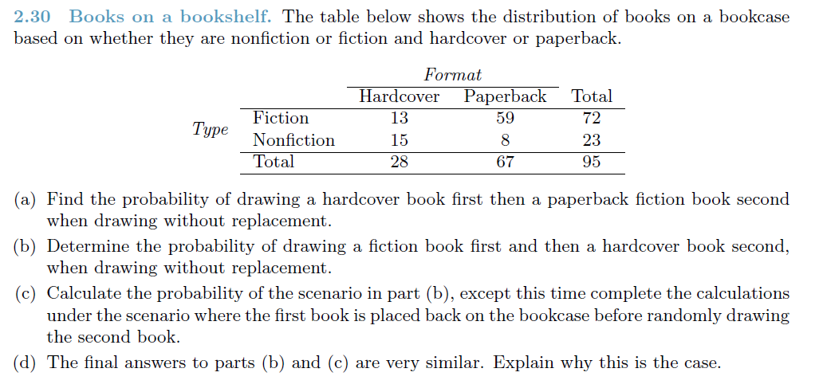

**Ans:**

1. (28 / 95) * (59 / 94) = 0.2947 * 0.6277 **= 0.1849 = 18.49%**
2. (72 / 95) * (28 / 94) = 0.7579 * 0.2979 **= 0.2258 = 22.58%**
3. (72 / 95) * (28 / 95) = 0.7579 * 0.2947 **= 0.2234 = 22.34%**
4. The sample size is small compared to the population. In such cases, the observations are nearly independent even when sampling without replacement.

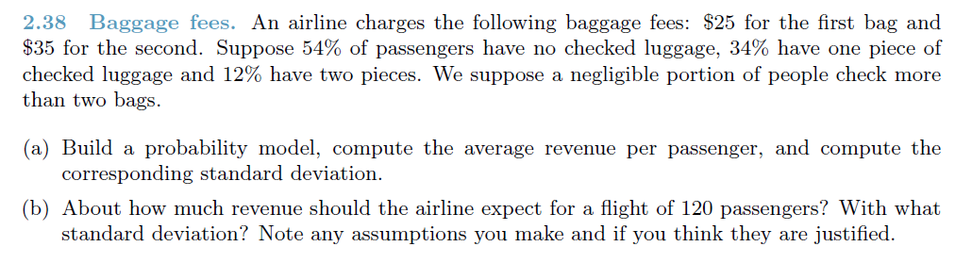

**Ans:**

|  |  |  |  |  |
| --- | --- | --- | --- | --- |
| **Event** | **X** | **P(X)** | **Y = X * P(X)** | **Power(X - Y, 2)** |
| No Bags | $ - | 54% | $ - | $ 133.10 |
| 1 Bag | $ 25.00 | 34% | $ 8.50 | $ 29.41 |
| 2 Bags | $ 60.00 | 12% | $ 7.20 | $ 235.50 |
|  | | 100% | $ 15.70 | $ 398.01 |
|  |  |  |  |  |
| Average Revenue Per Passenger = | $ 15.70 |  |  |  |
| Variance = | $ 398.01 |  |  |  |
| SD = | 19.950188 |  |  |  |

1. Average Revenue per Passenger = $ 15.7

Standard Deviation = $ 19.95

1. Revenue for 120 passengers = ($15.7 * 120) = $ 1884.0

The SD would be the same about $ 19.95

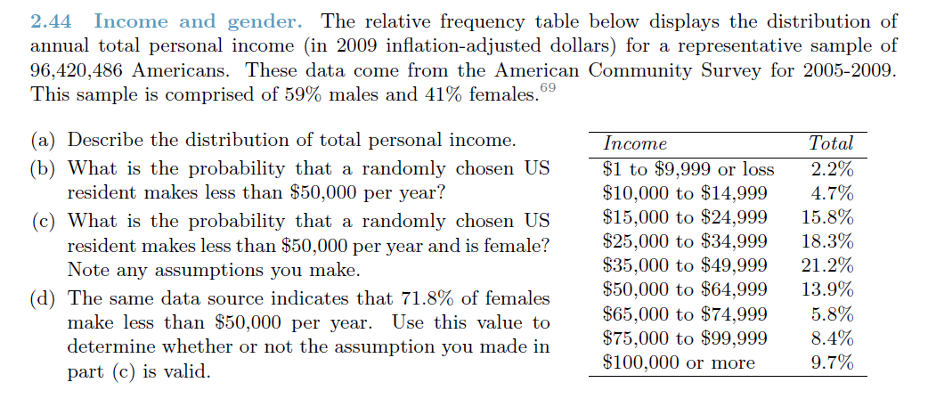

**Ans:**

1. The distribution looks to be unimodal with a slightly right skew with significant outliers.
2. P(< $50K) = (2.2% + 4.7% + 15.8% + 18.3% + 21.2%) **= 62.2%**
3. If we assume that P(Female) and P(< $50K) are independent, then

P(<$50K and Female) = P(< $50K) * P(Female) = 0.622 * 0.41 = **0.2550 = 25.5%**

1. With the new information we now have P(<$50K and Female) = 71.8%. This is significantly different from what we had before. Hence, I would conclude that my assumption of independence is not valid.